Height Map & Deformable Terrain Demo

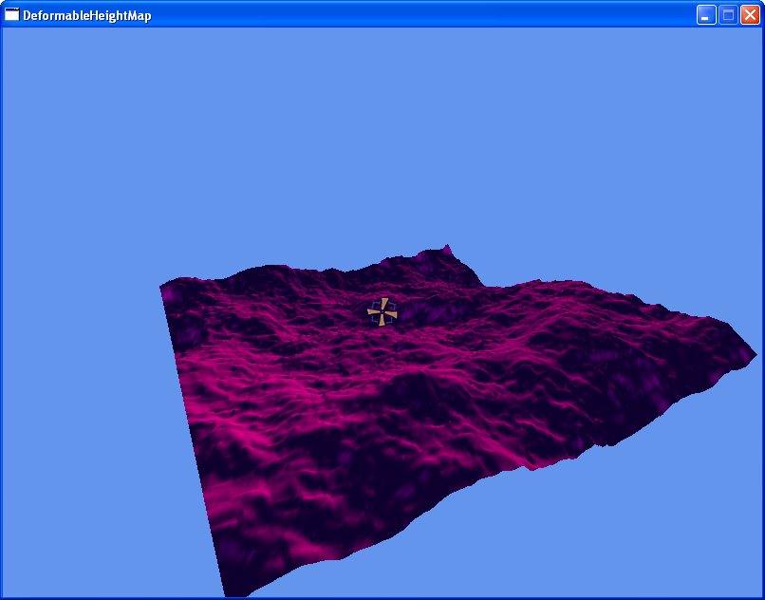

Summary

The demo provides a simple camera which can be flown around using the joypad. A 3d surface is created using a height map. Projectiles can be shot from the camera using the A button when these hit the surface they puncture holes in the surface and leave it deformed.

Classes

Avatar - inherits from Object

This is a simple implementation of how to render a 3D model. It contains a movement object which is used to define the movement of the model. There is a tick function which updates the position and the orientation. This is used for player and the projectiles which are fired. This class also handles the creation of a bounding sphere for the model.

Background

This creates the height map object and calls the render function. It also contains function calls for the background hits. It doesn’t actually render anything in this class. The background is rendered by the height map object.

Camera

This object contains the maths for the camera viewport.

Draw

Contains a class which is passed along the render pipeline, this contains a pointer to the camera object which is being used for the rendering in the current tick.

Math

This contains some general constants and maths functions not supports by the XNA framework.

Movement

Contains classes which define the movement of objects, these are then created within avatar constructors. These classes each define a specific type of movement i.e. movementFly allows full 3D movement without gravity, movementFPS contains code for a typical 3rd person shooter camera which includes gravity and hit checks against the background. The movementAvatar class contains a velocity which is applied to the position of the object each tick.

Object

This contains a basic implementation of any functions or properties that a real world object would require i.e. position and orientation.

Player

This is a wrapper for the camera. The player may change the type of camera which is required i.e. between Camera and CrossHairCamera. This also contains the creation of the projectile when it is fired.

Rotation

This contains code to handle the maths for rotations. It contains pitch, roll and yaw values and can be used to calculate additional data from these i.e. direction vector and rotation matrix.

Scene

This class holds all the objects for the demo which need to be drawn/ticked. It contains a list of avatar and a background object which are both ticked and drawn. A second list is used for any avatars which need to be destroyed, then at the end of the tick the avatars are removed from the scene.

CrossHairCamera – inherits from Camera

This is a slight variation on the camera object. The only difference is that is renders a sprite in the middle of the screen for a crosshair.

FractalTerrain – Inherits from Map

This is a class which uses a simple implementation of a Diamond-Square algorithm to generate a 3D fractal terrain. The base class handles all the rendering one the height map has been setup in the constructor.

HeightMap – Inherits from Map

This class uses a greyscale bitmap to produce 3D terrain. It creates the height map from the texture and then uses the Map object to render it. It also has a simple sweeping sphere hits system in it. The terrain can also be deformed using an ‘inverted’ height map, instead of having black for no height increase and white for maximum height increase, a colour of white will indicate the maximum height reduction.

Map

This takes the height map array and converts it into a form which can be rendered easily. There are 2 types of render variations implemented. The first is a triangle list and the second uses triangle strips.

Projectile – inherits from Avatar

This overrides the movement class to be a movementAvatar class and sets the velocity from the initial parameters. During the tick function hits are performed on the background and when a hit is detected it flags itself for deletion at the end of the scene and deforms the background at the point of contact.

RandomNumberGen – inherits from Random ( XNA class )

This provides some additional functions that aren’t supported by the XNA version of the class i.e. random numbers within ranges.

